**DETAIL DESIGN**



**Author: IMAGINEERS**

**Date: 23/02/2017**

**Revision history**

|  |  |  |  |
| --- | --- | --- | --- |
| **Version** | **Date** | **Author** | **Notes** |
| **1.0** | 23/02/2017 | Phuong Nguyen | Created |
|  |  |  |  |
|  |  |  |  |
|  |  |  |  |

Contents

I. INTRODUCTION 4

II. PROTOTYPE 4

1. SWAPPAL_MAIN SITE 4

2 SWAPPAL_CREATE PROFILE 5

2 SWAPPAL_INTRODUCTION LINE (head banner) 5

# INTRODUCTION

This document is created to show the design GUI or sketches of the Swappal website. This document is create for

* Scrum Team
* Product Owner

# PROTOTYPE

## SWAPPAL_MAIN SITE

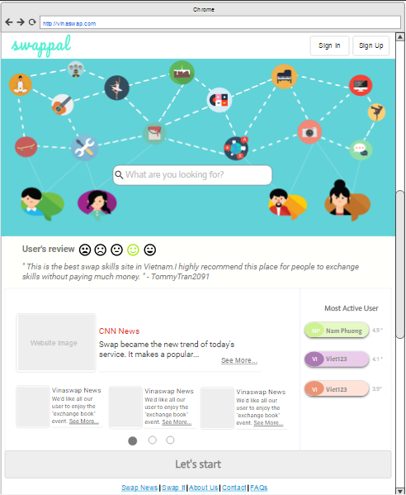

## SWAPPAL_CREATE PROFILE

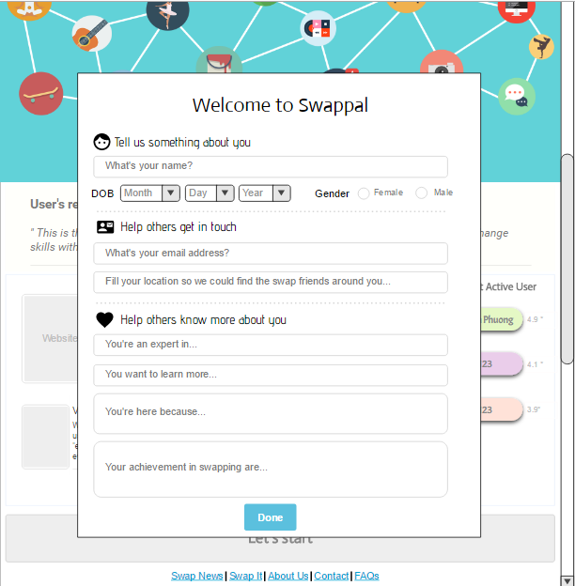

## SWAPPAL_INTRODUCTION LINE (head banner)

